NAME :- MENDPARA ANSH BHARATBHAI.

ROLL NO :- 21BIT123

SUBJECT :- DATA STRUCTURE AND ALGORITHMS

FACULTY :-DHARMESH SIR

List of Practical
Sr. No. | Name of Experiment | Date of Submission | Sign
1 | Basic Programming Concepts
2 | Searching Algorithms  - Linear  - Binary
3 | Stack Algorithms with Operations  - PUSH  - POP  - PEEP  - PEAK
4 | Queue Algorithms with Operations  - ENQUEUE  - DEQUEUE
5 | Circular Queue Algorithms with Operations  - C_ENQUEUE  - C_DEQUEUE
6 | Linked List Algorithms with Operations  - INSERT  - DELETE  - TRAVERSE and SERACH
7 | Doubly Linked List Algorithms with Operations  - INSERT  - DELETE
8 | Circular Linked List Algorithms with Operations  - INSERT  - DELETE
9 | BST Algorithms with Operations  - CREATE  - INSERT  - DELETE
10 | Sorting Algorithms  - SELECTION  - BUBBLE  - INSERTION  - QUICK  - MERGE

Practical 1
Basic Programming Concepts
- Write a program to Interchanging values using function and normal variables.

Program:

/* Interchanging values using function and normal variables */
#include <stdio.h>
#include <conio.h>
void main()
{
void interchange(int, int);
int x, y;
printf("Enter the first nubmer : ");
scanf("%d", &x);
printf("Enter the second nubmer : ");
scanf("%d", &y);

printf("Before calling function x=%d and y=%d\n", x, y);
interchange(x, y);
printf("After calling function x=%d and y=%d\n", x, y);
}
void interchange(int a, int b)
{
int temp;
temp = a;
a = b;
b = temp;
}

OUTPUT
======
Enter the first nubmer : 10
Enter the second nubmer : 20
Before calling function x=10 and y=20
After calling function x=10 and y=20

- Write a program to Interchanging values. Pass by reference

Program:

/* Interchanging values. Pass by reference */
#include <stdio.h>
#include <conio.h>
void interchange(int *a, int *b)
{
int temp = *a;
*a = *b;
*b = temp;
}
int main()
{
int x, y;

printf("Enter the first nubmer : ");
scanf("%d", &x);
printf("Enter the second nubmer : ");
scanf("%d", &y);

printf("Before function call x=%d y=%d \n", x, y);
interchange(&x, &y); // passing reference in function
printf("After function call x=%d y=%d \n", x, y);
return 0;
}

OUTPUT
======
Enter the first nubmer : 10
Enter the second nubmer : 20
Before function call x=10 y=20
After function call x=20 y=10

- Write a program to Interchanging values. Pass by Pointer
Program:
/* Interchanging values. Pass by Pointer */
#include <stdio.h>
#include <conio.h>
void main()
{
void interchange(int *, int *);
int x, y;

printf("Enter the first nubmer : ");
scanf("%d", &x);
printf("Enter the second nubmer : ");
scanf("%d", &y);

printf("Before calling function x=%d and y=%d\n", x, y);
interchange(&x, &y);
printf("After calling function x=%d and y=%d\n", x, y);
}
void interchange(int *a, int *b)
{
int temp;
temp = *a;
*a = *b;
*b = temp;
}

OUTPUT
======
Enter the first nubmer : 10
Enter the second nubmer : 20
Before calling function x=10 and y=20
After calling function x=20 and y=10

- Write a program to which demonstration of Function and array (Increment the value of every element of Array by 5. Incrimination should be performed by function.

Program:

/* Function and array */
#include <stdio.h>
#include <conio.h>
void main()
{
void changearray(int[]);
int a[5] = {10, 20, 30, 40, 50}, i;

printf("Before calling function\n");
for (i = 0; i < 5; ++i)
{
printf("%d\t", a[i]);
}
changearray(a);
printf("\nAfter calling function\n");
for (i = 0; i < 5; ++i)
{
printf("%d\t", a[i]);
}
}
void changearray(int b[5])
{
int i;
for (i = 0; i < 5; ++i)
{
b[i] = b[i] + 5;
;
}
}

OUTPUT
======
Before calling function
10 20 30 40 50
After calling function
15 25 35 45 55

- Write a program to create a Simple Structure student get and put information of a student.

Program:

#include <stdio.h>
#include <string.h>
struct student
{
char name[20];
int A_number;
};

struct student student_information();

int main()
{
struct student s;

s = student_information();

return 0;
}
struct student student_information()
{
struct student s1;

printf("Enter name: ");
scanf("%s", &s1.name);

printf("Enter A_number: ");
scanf("%d", &s1.A_number);

printf("Your name is : %s\n", s1.name);
printf("Your roll nubmer is : %d\n", s1.A_number);
}

OUTPUT
======
Your name is : ansh
Your roll nubmer is : 123

- Write a program to accessing structure using pointer

Program:

/* Accessing structure using pointer */
#include <stdio.h>
#include <conio.h>
#include <string.h>
struct student
{
char name[20];
int age;
};
void main()
{
struct student *s;

printf("\nEnter Name : ");
scanf("%s", s->name);

printf("Enter age : ");
scanf("%d", &s->age);

printf("Your name is : %s\n", s->name);
printf("Your age is : %d\n", s->age);
}

OUTPUT
======
Your name is : Ansh
Your age is : 18

- Write a program for input and output structure members by function.
Program:
/* Structure and function */
#include <stdio.h>
#include <conio.h>
#include <string.h>
struct student
{
char name[20];
int A_number;
};
void main()
{
struct student s1;
void change(student);

printf("Enter name: ");
scanf("%s", &s1.name);

printf("Enter A_number: ");
scanf("%d", &s1.A_number);

printf("Before calling function\n");

printf("Your name is : %s\n", s1.name);
printf("Your roll nubmer is : %d\n", s1.A_number);

change(s1);
}
void change(struct student s2)
{
printf("Enter name: ");
scanf("%s", &s2.name);

printf("Enter A_number: ");
scanf("%d", &s2.A_number);

printf("After calling function\n");

printf("Your name is : %s\n", s2.name);
printf("Your roll nubmer is : %d\n", s2.A_number);
}

OUTPUT
======
Enter name: ansh
Enter A_number: 123
Before calling function
Your name is : ansh
Your roll nubmer is : 123
Enter name: malay
Enter A_number: 100
After calling function
Your name is : malay
Your roll nubmer is : 100

- Write a program to Structure and function returning structure.
Program:
/* Structure and function retuning structure */
#include <stdio.h>
#include <conio.h>
#include <string.h>
struct student
{
char name[20];
int A_number;
};
void main()
{
struct student s1, s2;
struct student change(student);

printf("Enter name: ");
scanf("%s", &s1.name);

printf("Enter A_number: ");
scanf("%d", &s1.A_number);
printf("Before calling function\n");

printf("Your name is : %s\n", s1.name);
printf("Your roll nubmer is : %d\n", s1.A_number);

s2 = change(s1);
printf("After calling function\n");
printf("Your name is : %s\n", s2.name);
printf("Your roll nubmer is : %d\n", s2.A_number);
}
struct student change(struct student s2)
{
printf("Enter name: ");
scanf("%s", &s2.name);

printf("Enter A_number: ");
scanf("%d", &s2.A_number);

return s2;
}

OUTPUT
======
Enter name: ansh
Enter A_number: 123
Before calling function
Your name is : ansh
Your roll nubmer is : 123
Enter name: malay
Enter A_number: 100
After calling function
Your name is : malay
Your roll nubmer is : 100

- Write a program for details of five students using array of structure

Program:

/* Array of structure */
#include <stdio.h>
#include <conio.h>
struct student
{
char name[20];
int A_number;
};
void main()
{
int n;
printf("Enter the number for how many student are in this list : ");
scanf("%d", &n);
struct student s[n];
int i;

for (i = 0; i < n; ++i)
{
printf("Student : %d\n", i + 1);
printf("Name : ");
scanf("%s", s[i].name);
printf("A_number : ");
scanf("%d", &s[i].A_number);
}

printf("You student list is : \n");

for (i = 0; i < n; ++i)
{
printf("Student : %d\nName : %s A_number : %d\n", i + 1, s[i].name, s[i].A_number);
}
}

OUTPUT
======
Enter the number for how many student are in this list : 5
Student : 1
Name : ansh
A_number : 123
Student : 2
Name : malay
A_number : 100
Student : 3
Name : ronit
A_number : 130
Student : 4
Name : ohm
A_number : 95
Student : 5
Name : daksh
A_number : 107
You student list is :
Student : 1
Name : ansh A_number : 123
Student : 2
Name : malay A_number : 100
Student : 3
Name : ronit A_number : 130
Student : 4
Name : ohm A_number : 95
Student : 5
Name : daksh A_number : 107

- Write a program for details of five students using array of structure and pointer

Program:

/* Array of structure and pointer */
#include <stdio.h>
#include <conio.h>
#include <stdlib.h>
struct student
{
char name[20];
int A_number;
};
void main()
{
int n;
printf("Enter the number for how many student are in this list : ");
scanf("%d", &n);

struct student *s;

s = (struct student *)malloc(n * sizeof(struct student));

for (int i = 0; i < n; ++i)
{
printf("Student : %d\n", i + 1);
printf("Name : ");
scanf("%s", (s + i)->name);
printf("A_number : ");
scanf("%d", &(s + i)->A_number);
}

printf("You list is : \n");

for (int i = 0; i < n; ++i)
{
printf("Student : %d \nName : %s A_number : %d\n", i + 1, (s + i)->name, (s + i)->A_number);
}
}

OUTPUT
======
Enter the number for how many student are in this list : 5
Student : 1
Name : ansh
A_number : 123
Student : 2
Name : daksh
A_number : 107
Student : 3
Name : malay
A_number : 100
Student : 4
Name : ronit
A_number : 130
Student : 5
Name : ohm
A_number : 95
You list is :
Student : 1
Name : ansh A_number : 123
Student : 2
Name : daksh A_number : 107
Student : 3
Name : malay A_number : 100
Student : 4
Name : ronit A_number : 130
Student : 5
Name : ohm A_number : 95

Practical 2
Searching Algorithms
- Linear
- Binary

- Linear search
Program:

#include <stdio.h>
#include <conio.h>

void linear_search(int a[], int n, int key);

int main()
{
int n;
printf("Enter size of array :- ");
scanf("%d", &n);
int a[n];
for (int i = 0; i < n; i++)
{
int k;
printf("Enter the value : ");
scanf("%d", &k);
a[i] = k;
}

int key;
printf("Enter the key : ");
scanf("%d", &key);

linear_search(a, n, key);

return 0;
}

void linear_search(int a[], int n, int key)
{
int cnt = 0;
int pos = 0;
for (int i = 0; i < n; i++)
{
if (a[i] == key)
{
pos = i;
cnt++;
}
}
if (cnt > 0)
{
printf("your element position is %d ", pos + 1);
}
else
{
printf("element not found");
}
}

OUTPUT
======

Enter size of array :- 5
Enter the value : 1
Enter the value : 3
Enter the value : 2
Enter the value : 4
Enter the value : 5
Enter the key : 2
your element position is 3

- Binary search
Program:

#include <bits/stdc++.h>
#include <iostream>

void binary_search(int a[], int n, int key);

int main()
{
int n;
printf("Enter size of array :- ");
scanf("%d", &n);
int a[n];
for (int i = 0; i < n; i++)
{
int k;
printf("Enter the value : ");
scanf("%d", &k);
a[i] = k;
}

int max = a[0];
for (int i = 0; i < n; i++)
{
if (a[i] > a[i + 1])
{
int temp;
temp = a[i + 1];
a[i + 1] = a[i];
a[i] = temp;
}
else
{
a[i] = a[i];
}
}

int key;
printf("Enter the key : ");
scanf("%d", &key);

binary_search(a, n, key);
}

void binary_search(int a[], int n, int key)
{

int first = 0;
int last = n;
for (int i = 0; i < n; i++)
{
int mid = (first + last) / 2;

if (key == a[mid])
{
printf("your value is found in %d position ", mid + 1);
break;
}
else
{
if (a[mid] <= key)
{
first = mid + 1;
}
else
{
last = mid - 1;
}
}
}
}

OUTPUT
======

Enter size of array :- 5
Enter the value : 2
Enter the value : 1
Enter the value : 3
Enter the value : 4
Enter the value : 5
Enter the key : 4
your value is found in 4 position

Practical 3
3 | Stack Algorithms with Operations  - PUSH  - POP  - PEEP  - PEAK  Program:  #include <stdio.h>  #include <stdlib.h>  #define size 5  int top = -1, array[size];  void push();  void pop();  void peek1();  int peek(int array[]);  void show();  void peep();  int main()  {  int choice;  while (1)  {  printf("\noperations performed by stack ");  printf("\n1.Push the element\n2.Pop the element\n3.peek the element\n4.peep the element\n5.Show\n6.End");  printf("\n\n-> Enter the choice : ");  scanf("%d", &choice);  switch (choice)  {  case 1:  push();  break;  case 2:  pop();  break;  case 3:  peek1();  break;  case 4:  peep();  break;  case 5:  show();  break;  case 6:  exit(0);  default:  printf("\n-> Invalid choice!! ");  }  }  }  void push()  {  int x;  if (top == size - 1)  {  printf("stack is overflow!!");  }  printf("\n-> Enter elemente to be inserted to the array : ");  scanf("%d", &x);  top = top + 1;  array[top] = x;  }  void pop()  {  if (top == -1)  {  printf("\n-> Underflow!!");  }  printf("\n-> popped element is %d", array[top]);  top = top - 1;  }  void show()  {  if (top == -1)  {  printf("\n-> Underflow!!");  }  else  {  printf("\n-> Elements present in the array : \n");  for (int i = top; i >= 0; --i)  {  printf("%d\n", array[i]);  }  }  }  void peek1()  {  top = peek(array);  if (top != -1)  {  printf("\n-> The value stored at top of array is %d ", top);  }  }  int peek(int array[])  {  if (top == -1)  {  printf("\n-> array is empty ");  return -1;  }  else  {  return (array[top]);  }  }  void peep()  {  int p;  printf("\nEnter the position : ");  scanf("%d", &p);  if (top - p <= -1)  {  printf("\narray is overflow !!!");  }  else  {  printf("\nThe Elements is : %d", array[top - p + 1]);  }  }  OUTPUT  ======  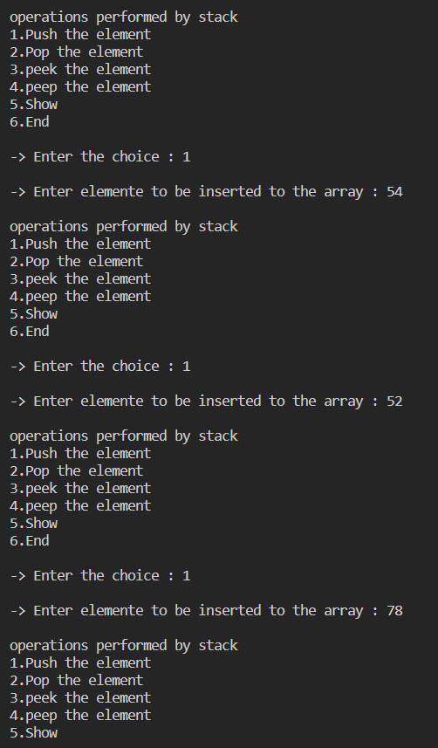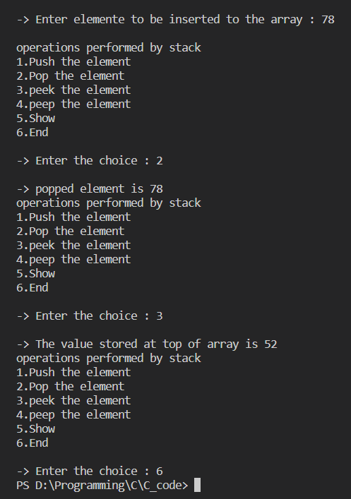

Practical 4
Queue Algorithms with Operations
- ENQUEUE
- DEQUEUE

Program :
#include <stdio.h>
#include <stdlib.h>

#define size 5

int a[size];
int f = -1;
int r = -1;

void enqueue();
void dequeue();
void peek1();
void display();

int main()
{
int choice;
while (1)
{
printf("\noperations performed : ");
printf("\n1.enqeue \n2.dequeue \n3.peak \n4.display \n5.exit ");
printf("\n\n-> Enter the choice : ");
scanf("%d", &choice);

switch (choice)
{
case 1:
enqueue();
break;
case 2:
dequeue();
break;
case 3:
peek1();
break;
case 4:
display();
break;
case 5:
exit(0);
break;

default:
printf("\n-> Invalid choice!! ");
}
}
}

void enqueue()
{
int x;
printf("Enter the value : ");
scanf("%d", &x);

if (r == size - 1)
{
printf("overflow");
}
if ((r == -1) && (f == -1))
{
f = 0;
r = 0;
}
else
{
r++;
}
a[r] = x;
}

void dequeue()
{
if ((r == -1) && (f == -1))
{
printf("queue is empty");
}
else
{
printf("deleted element is : %d ", a[f]);
f++;
}
}

void peek1()
{
if ((r == -1) && (f == -1))
{
printf("queue is empty");
}
else
{
printf("your peak element is %d ", a[f]);
}
}

void display()
{
if ((r == -1) && (f == -1))
{
printf("queue is empty");
}
else
{
for (int i = f; i <= r; i++)
{
printf("%d ", a[i]);
}
}
}

OUTPUT
======

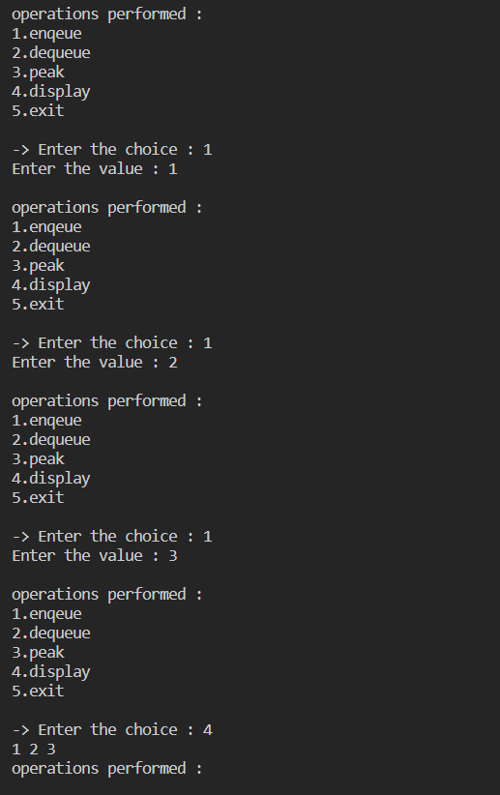

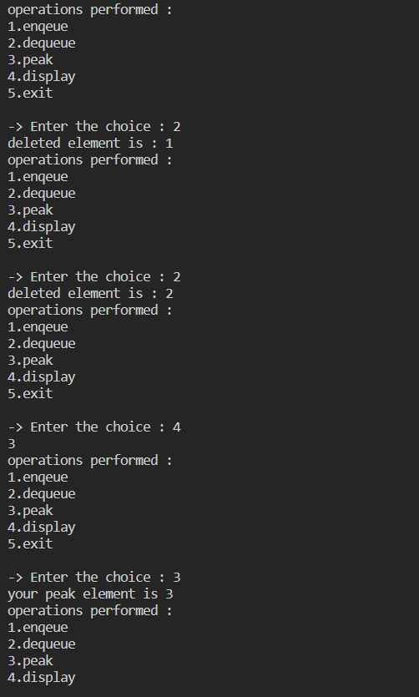
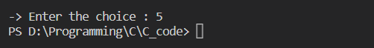

Practical 5
Circular Queue Algorithms with Operations
  - C_ENQUEUE
  - C_DEQUEUE

Program :
#include <stdio.h>
#include <stdlib.h>

#define size 10

int a[size];
int f = -1;
int r = -1;

void enqueue();
void dequeue();

int main()
{

int choice;
while (1)
{
printf("\noperations performed : ");
printf("\n1.enqeue \n2.dequeue \n3.exit ");
printf("\n\n-> Enter the choice : ");
scanf("%d", &choice);

switch (choice)
{
case 1:
enqueue();
break;
case 2:
dequeue();
break;
case 3:
exit(0);
break;

default:
printf("\n-> Invalid choice!! ");
}
}
}

void enqueue()
{
int x;
printf("Enter the value : ");
scanf("%d", &x);
if ((r + 1) % size == f)
{
printf("queue is full");
}
if (f == -1 && r == -1)
{
f = 0;
r = 0;
}
else if ((size - 1) && (f != 0))
{
r = 0;
}
else
{
r = (r + 1) % size;
}
a[r] = x;
}

void dequeue()
{
if ((f == -1))
{
printf("queue is empty");
}
printf("deleted element is %d ", a[f]);

if (f == r)
{
f = -1;
r = -1;
}
else
{
if (f == (size - 1))
{
f = 0;
}
else
{
f = (f + 1) % size;
}
}
}

OUTPUT
======

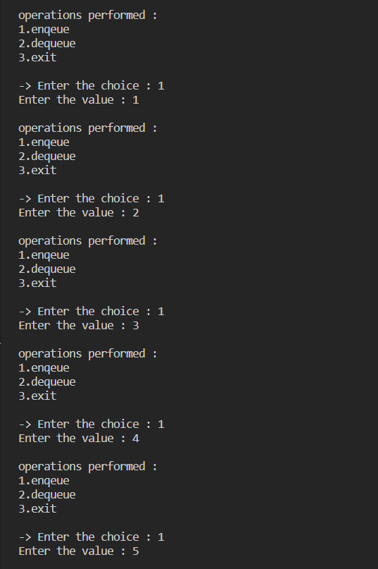

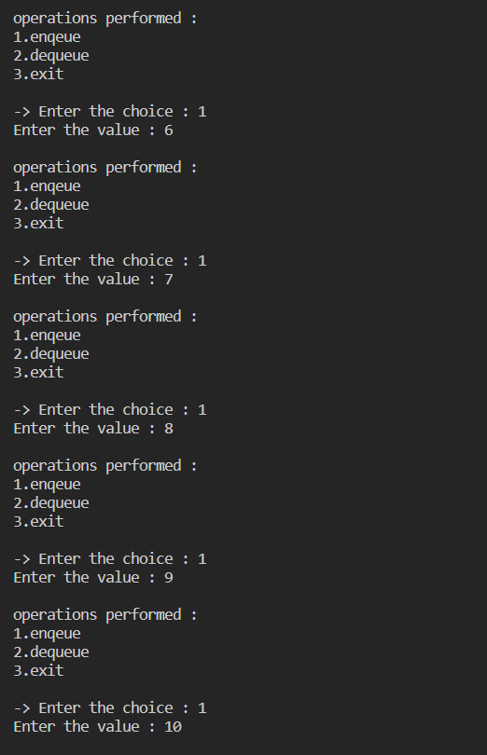

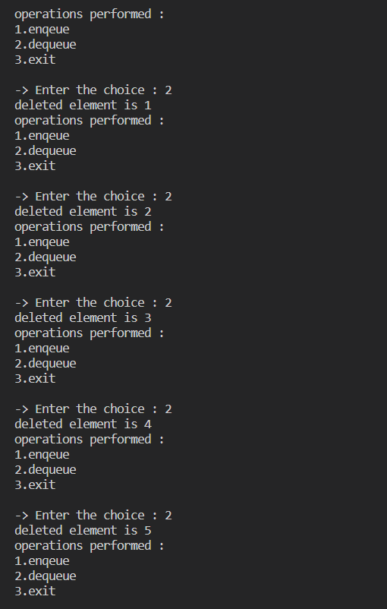

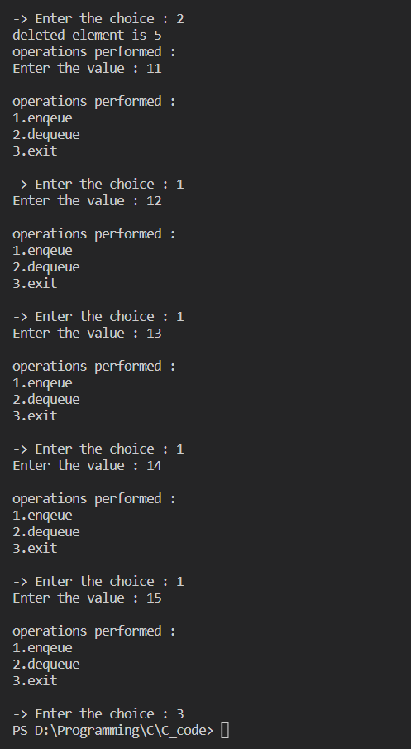
Date: | Signature

Practical 6
Linked List Algorithms with Operations
- INSERT
- DELETE
- TRAVERSE and SEARCH

Program:
#include<stdio.h>
#include<conio.h>
struct node
{
int data;
struct node *next;
};
int value;
int va;
int vb;
struct node *start = NULL;
int main()
{
int n;

while(1)
{
printf("\n");
printf("1.) Insert at begin\n");
printf("2.) Insert at end\n");
printf("3.) Insert after value\n");
printf("4.) Insert before value\n");
printf("5.) Delete at begin\n");
printf("6.) Delete at end\n");
printf("7.) Delete after value\n");
printf("8.) Delete before value\n");
printf("9.) Display\n");
printf("10.) Exit\n");
printf("Enter you choice : ");
scanf("%d", &n);
printf("\n");
switch(n)
{
case 1:

printf("Enter the value you want to enter : ");
scanf("%d", &value);
printf("\n");
start = insert_at_begin(start, value);
printf("\n");
break;
case 2:
printf("Enter the value you want to enter : ");
scanf("%d", &value);
printf("\n");
insert_at_end(start,value);
printf("\n");
break;
case 3:

printf("Enter the value you want to enter : \n");
scanf("%d", &value);
printf("Enter the value after you want to enter : ");
scanf("%d", &va);
printf("\n");
insert_after(start,value,va);
printf("\n");
break;
case 4:
printf("Enter the value you want to enter : \n");
scanf("%d", &value);
printf("Enter the value before you want to enter : ");
scanf("%d", &vb);
printf("\n");
insert_before(start,value,vb);
printf("\n");
break;
case 5:
delete_at_begin();
break;
case 6:
delete_at_end();
break;
case 7:
printf("Enter the value after you want to delete : ");
scanf("%d", &va);
delete_after(start,va);
break;
case 8:
printf("Enter the value before you want to delete : ");
scanf("%d", &vb);
delete_before(start,vb);
break;
case 9:
display();
break;
case 10:
exit(0);
break;
default:
printf("Enter the correct choice");
}
}

}
void insert_at_begin(struct node *start, int value)
{
struct node *new_node;
new_node = (struct node *)malloc(sizeof(struct node));
new_node->data = value;
new_node->next = start;
start = new_node;
}
void insert_at_end(struct node *start, int value)
{
struct node *ptr;
ptr = start;
while((ptr->next)!=NULL)
{
ptr=ptr->next;
}
struct node *new_node;
new_node = (struct node *)malloc(sizeof(struct node));
new_node->data = value;
new_node->next = NULL;
ptr->next=new_node;
}
void insert_after(struct node *start, int value,int va)
{
struct node *ptr;
ptr = start;
while(ptr->data!=va)
{
ptr=ptr->next;
}
struct node *new_node;
new_node = (struct node *)malloc(sizeof(struct node));
new_node->data = value;
new_node->next = ptr->next;
ptr->next=new_node;
}
void insert_before(struct node *start, int value,int vb)
{
struct node *ptr;
struct node *new_node;
new_node = (struct node *)malloc(sizeof(struct node));
new_node->data = value;
ptr=start;
while (ptr->next->data != vb)
{
ptr = ptr->next;
}
new_node->next = ptr->next;
ptr->next = new_node;
}
void delete_at_begin()
{
if (start == NULL)
{
printf("EMPTY");
}
else
{
struct node *ptr;
ptr=start;
start = start->next;
printf("the deleted element is: %d",ptr->data);
free(ptr);
}
}
void delete_at_end()
{
if (start == NULL)
{
printf("EMPTY");
}
else
{
struct node *ptr;
struct node *preptr;
ptr=start;
while(ptr->next!=NULL)
{
preptr=ptr;
ptr=ptr->next;
}
preptr->next = NULL;
printf("the deleted element is: %d",ptr->data);
free(ptr);
}
}
void delete_after(struct node *start,int va)
{
struct node *ptr;
struct node *preptr;
ptr = start;
preptr=start;
while(preptr->data!=va)
{
preptr=ptr;
ptr=ptr->next;
}
preptr->next=ptr->next;
printf("the deleted element is: %d",ptr->data);
free(ptr);
}
void delete_before(struct node *start,int vb)
{
struct node *ptr;
struct node *preptr;
ptr = start;
preptr=start;
while(ptr->next->data!=vb)
{
preptr=ptr;
ptr=ptr->next;
}
preptr->next=ptr->next;
printf("the deleted element is: %d",ptr->data);
free(ptr);
}
void display()
{
struct node *ptr ;
ptr= start;
while(ptr!=NULL)
{
printf("%d -> ",ptr->data);
ptr=ptr->next;
}
printf("NULL");
}

OUTPUT
=======

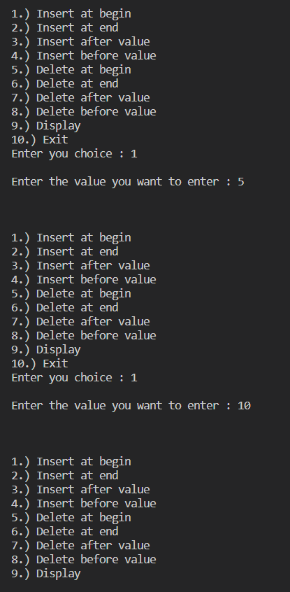

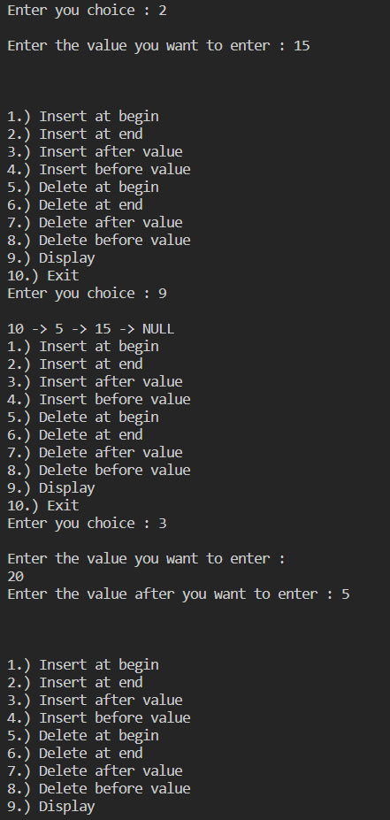

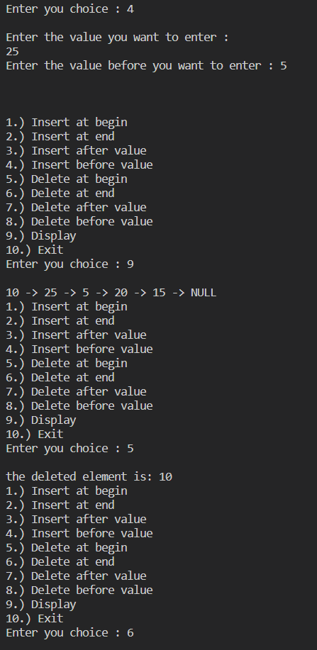

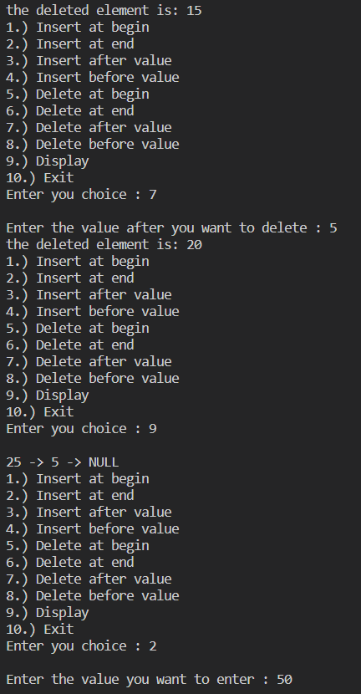

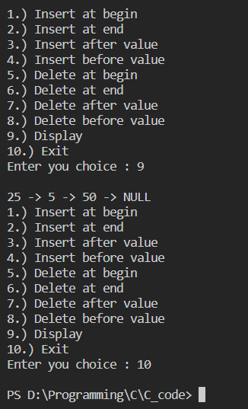

Date: | Signature

Practical 7
Doubly Linked List Algorithms with Operations
- INSERT
- DELETE

Program:
#include<stdio.h>
#include<conio.h>
struct node
{
int data;
struct node *next,*pre;
};
int value;
int va;
int vb;
struct node *start = NULL;
int main()
{
int n;
while(1)
{
printf("\n");
printf("1.) Insert at begin\n");
printf("2.) Insert at end\n");
printf("3.) Insert after value\n");
printf("4.) Insert before value\n");
printf("5.) Delete at begin\n");
printf("6.) Delete at end\n");
printf("7.) Delete after value\n");
printf("8.) Delete before value\n");
printf("9.) Display\n");
printf("10.) Exit\n");
printf("Enter you choice : ");
scanf("%d", &n);
printf("\n");
switch(n)
{
case 1:
printf("Enter the value you want to enter : ");
scanf("%d", &value);
printf("\n");
start = insert_at_begin(start, value);
printf("\n");
break;
case 2:
printf("Enter the value you want to enter : ");
scanf("%d", &value);
printf("\n");
insert_at_end(start,value);
printf("\n");
break;
case 3:
printf("Enter the value you want to enter : \n");
scanf("%d", &value);
printf("Enter the value after you want to enter : ");
scanf("%d", &va);
printf("\n");
insert_after(start,value,va);
printf("\n");
break;
case 4:
printf("Enter the value you want to enter : \n");
scanf("%d", &value);
printf("Enter the value before you want to enter : ");
scanf("%d", &vb);
printf("\n");
insert_before(start,value,vb);
printf("\n");
break;
case 5:
delete_at_begin();
break;
case 6:
delete_at_end();
break;
case 7:
printf("Enter the value after you want to delete : ");
scanf("%d", &va);
delete_after(start,va);
break;
case 8:
printf("Enter the value before you want to delete : ");
scanf("%d", &vb);
delete_before(start,vb);
break;
case 9:
display();
break;
case 10:
exit(0);
break;
default:
printf("Enter the correct choice");
}
}
}
void insert_at_begin(struct node *start, int value)
{
struct node *new_node;
new_node = (struct node *)malloc(sizeof(struct node));
new_node->data = value;
new_node->next = start;
new_node->pre = NULL;
start = new_node;
}
void insert_at_end(struct node *start, int value)
{
struct node *ptr;
ptr = start;
while((ptr->next)!=NULL)
{
ptr=ptr->next;
}
struct node *new_node;
new_node = (struct node *)malloc(sizeof(struct node));
new_node->data = value;
new_node->next = NULL;
new_node->pre=ptr;
ptr->next=new_node;
}
void insert_after(struct node *start, int value,int va)
{
struct node *ptr;
ptr = start;
while(ptr->data!=va)
{
ptr=ptr->next;
}
struct node *new_node;
new_node = (struct node *)malloc(sizeof(struct node));
new_node->data = value;
new_node->next = ptr->next;
ptr->next=new_node;
new_node->pre=ptr;
}
void insert_before(struct node *start, int value,int vb)
{
struct node *ptr;
struct node *new_node;
new_node = (struct node *)malloc(sizeof(struct node));
new_node->data = value;
ptr=start;
while (ptr->next->data != vb)
{
ptr = ptr->next;
}
new_node->next = ptr->next;
ptr->next = new_node;
new_node->pre=ptr;
}
void delete_at_begin()
{
if (start == NULL)
{
printf("EMPTY");
}
else
{
struct node *ptr;
ptr=start;
start = start->next;
start->pre = NULL;
printf("the deleted element is: %d",ptr->data);
free(ptr);
}
}
void delete_at_end()
{
if (start == NULL)
{
printf("EMPTY");
}
else
{
struct node *ptr,*preptr;
ptr=start;
while(ptr->next!=NULL)
{
preptr=ptr;
ptr=ptr->next;
}
preptr->next = NULL;
printf("the deleted element is: %d",ptr->data);
free(ptr);
}
}
void delete_after(struct node *start,int va)
{
struct node *ptr;
struct node *preptr;
ptr = start;
preptr=start;
while(preptr->data!=va)
{
preptr=ptr;
ptr=ptr->next;
}
preptr->next=ptr->next;
ptr->next->pre=preptr;
printf("the deleted element is: %d",ptr->data);
free(ptr);
}
void delete_before(struct node *start,int vb)
{
struct node *ptr,*preptr;
ptr = start;
while(ptr->next->data!=vb)
{
preptr=ptr;
ptr=ptr->next;
}
preptr->next=ptr->next;
ptr->next->pre=preptr;
printf("the deleted element is: %d",ptr->data);
free(ptr);
}
void display()
{
struct node *ptr ;
ptr= start;
while(ptr!=NULL)
{
printf("%d -> ",ptr->data);
ptr=ptr->next;
}
printf("NULL");
}

OUTPUT
=======

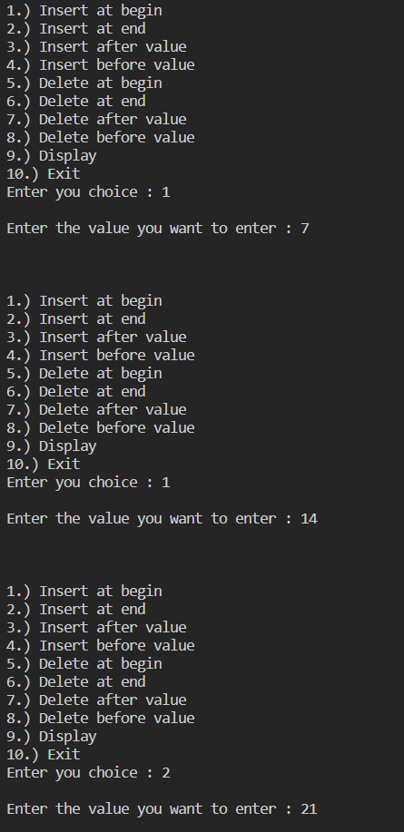

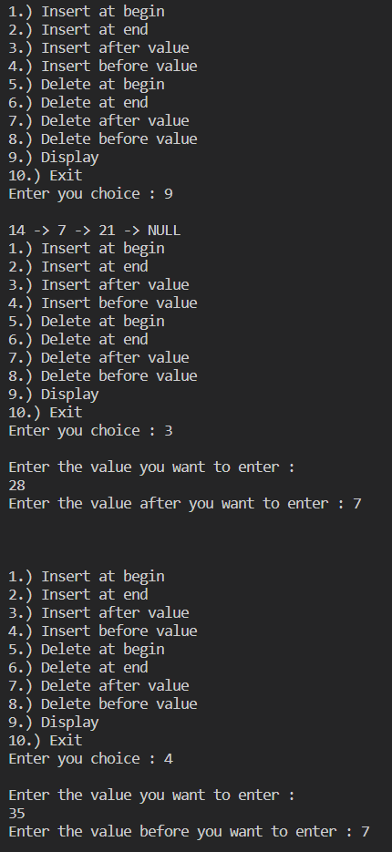

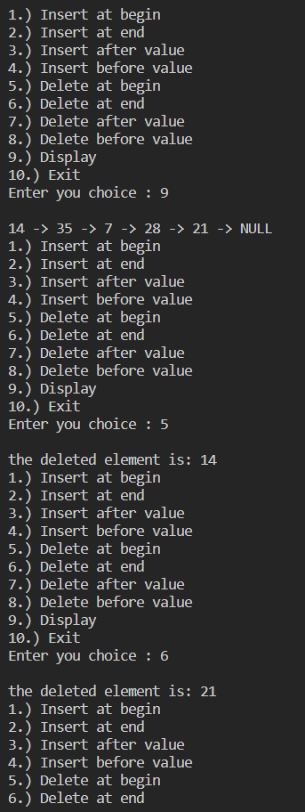

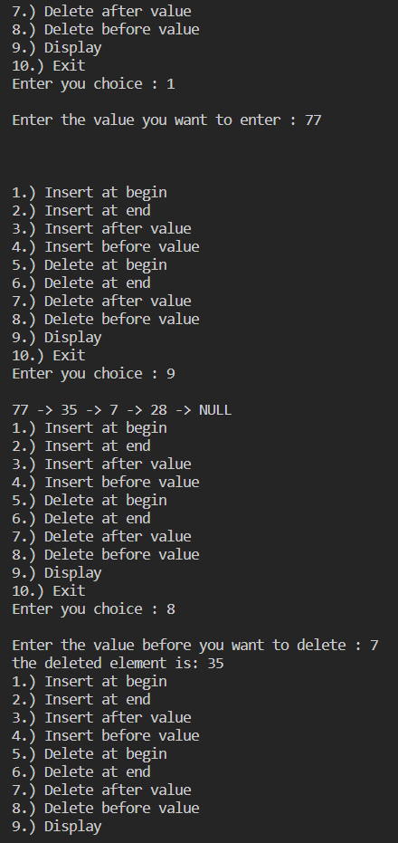

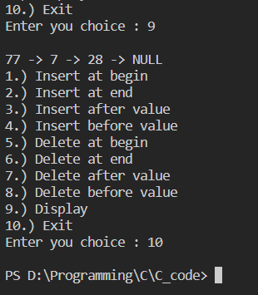

Date: | Signature

Practical 8
Circular Linked List Algorithms with Operations
- INSERT
- DELETE

Program:
#include <stdio.h>
#include <stdlib.h>
struct node
{
int data;
struct node *link;
} *head = NULL, *ptr, *preptr;
void insert_beg()
{
ptr = (struct node *)malloc(sizeof(struct node));
int d;
printf("\nEnter data : ");
scanf("%d", &d);
ptr->data = d;
ptr->link = NULL;
if (head == NULL)
{
head = ptr;
ptr->link = head;
}
else
{
preptr = head;
while (preptr->link != head)
{
preptr = preptr->link;
}
ptr->link = head;
preptr->link = ptr;
head = ptr;
}
}
void insert_end()
{
ptr = (struct node *)malloc(sizeof(struct node));
int d;
printf("\nEnter data : ");
scanf("%d", &d);
ptr->data = d;
ptr->link = NULL;
if (head == NULL)
{
head = ptr;
ptr->link = head;
}
else
{
preptr = head;
while (preptr->link != head)
{
preptr = preptr->link;
}
preptr->link = ptr;
ptr->link = head;
}
printf("\nINSERTED");
}
void display()
{
if (head == NULL)
{
printf("\nCLL EMPTY");
}
else
{
ptr = head;
printf("%d ", ptr->data);
while (ptr->link != head)
{
ptr = ptr->link;
printf("%d ", ptr->data);
}
}
}
void delete_beg()
{
if (head == NULL)
{
printf("\nSLL EMPTY");
}
else
{
ptr = head;
while (ptr->link != head)
{
ptr = ptr->link;
}
ptr->link = head->link;
free(head);
head = ptr->link;
}
printf("\nDeleted");
}
void delete_end()
{
if (head == NULL)
{
printf("\nSLL EMPTY");
}
else
{
ptr = head;
while (ptr->link != head)
{
preptr = ptr;
ptr = ptr->link;
}
preptr->link = head;
free(ptr);
}
printf("\nDeleted");
}
int main()
{
int ch;
while (1)
{
printf("\n1.insert");
printf("\n2.delete");
printf("\n3.display");
printf("\n4.Exit");
printf("\nEnter your choice : ");
scanf("\n%d", &ch);
switch (ch)
{
case 1:
printf("\n1.insert at beginning");
printf("\n2.insert at end");
printf("\n3.Exit");
printf("\nEnter your choice : ");
scanf("\n%d", &ch);
switch (ch)
{
case 1:
insert_beg();
break;
case 2:
insert_end();
break;
case 3:
exit(0);
}
break;
case 2:
printf("\n1.delete at beginning");
printf("\n2.delete at end");
printf("\n3.Exit");
printf("\nEnter your choice : ");
scanf("\n%d", &ch);
switch (ch)
{
case 1:
delete_beg();
break;
case 2:
delete_end();
break;
case 3:
exit(0);
}
break;
case 3:
display();
break;
case 4:
exit(0);
}
}
return 0;
}

OUTPUT
=======

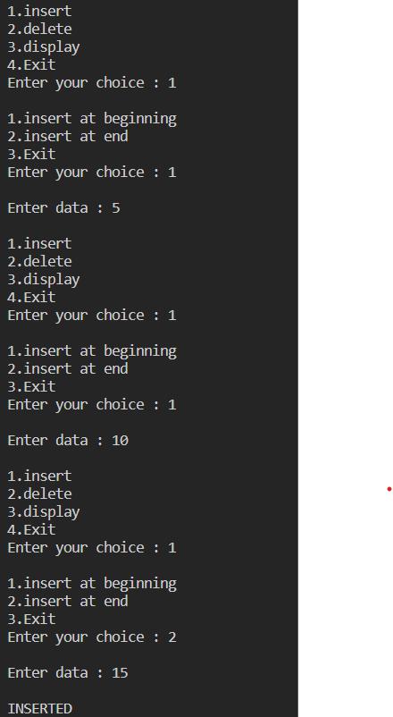

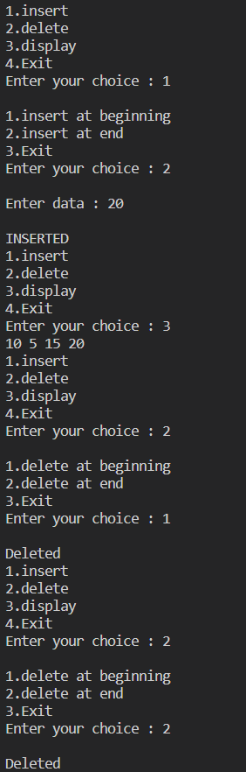

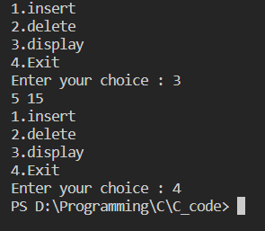

Date: | Signature

Practical 10
10 | Sorting Algorithms  - SELECTION  - BUBBLE  - INSERTION  - QUICK  - MERGE

1) Selection sort
Program:
#include <stdio.h>
#include <stdlib.h>
int main()
{
int n;
printf("Enter the array size : ");
scanf("%d", &n);
int a[n];
for (int i = 0; i < n; i++)
{
int c;
printf("Enter element : ");
scanf("%d", &c);
a[i] = c;
}

for (int i = 0; i < n - 1; i++)
{
int min = i;
for (int j = i + 1; j < n; j++)
{
if (a[j] <= a[min])
{
min = j;
}
}
int temp;
temp = a[i];
a[i] = a[min];
a[min] = temp;
}

for (int k = 0; k < n; k++)
{
printf("%d ", a[k]);
}

return 0;
}

OUTPUT
=======

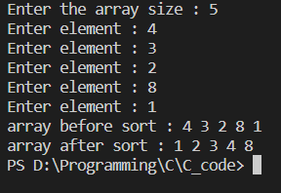

2) bubble sort
Program:
#include <stdio.h>
#include <stdlib.h>
int main()
{
int n;
printf("Enter the array size : ");
scanf("%d", &n);
int a[n];
for (int i = 0; i < n; i++)
{
int c;
printf("Enter element : ");
scanf("%d", &c);
a[i] = c;
}

for (int i = 1; i < n; i++)
{
for (int j = 0; j < n - i; j++)
{
if (a[j] > a[j + 1])
{
int temp;
temp = a[j];
a[j] = a[j + 1];
a[j + 1] = temp;
}
}
}

for (int k = 0; k < n; k++)
{
printf("%d ", a[k]);
}

return 0;
}

OUTPUT
=======

3) insertion sort
Program:
#include <stdio.h>
#include <stdlib.h>
int main()
{
int n;
printf("Enter the array size : ");
scanf("%d", &n);
int a[n];
for (int i = 0; i < n; i++)
{
int c;
printf("Enter element : ");
scanf("%d", &c);
a[i] = c;
}

for (int i = 1; i < n; i++)
{
int key = a[i];
int j = i - 1;
while (j >= 0 && a[j] >= key)
{
a[j + 1] = a[j];
j = j - 1;
}
a[j + 1] = key;
}

for (int k = 0; k < n; k++)
{
printf("%d ", a[k]);
}

return 0;
}

OUTPUT
=======

4) quick sort
Program:
#include <stdio.h>
#include <stdlib.h>

void printarray(int *a, int n)
{
for (int i = 0; i < n; i++)
{
printf("%d ", a[i]);
}
printf("\n");
}

int partition(int a[], int low, int high)
{
int pivot = a[low];
int i = low + 1;
int j = high;
int temp;

do
{
while (a[i] <= pivot)
{
i++;
}
while (a[j] > pivot)
{
j--;
}
if (i < j)
{
temp = a[i];
a[i] = a[j];
a[j] = temp;
}

} while (i < j);

temp = a[low];
a[low] = a[j];
a[j] = temp;
return j;
}

void quicksort(int a[], int low, int high)
{
int partitionindex;
if (low < high)
{
partitionindex = partition(a, low, high);
quicksort(a, low, partitionindex - 1);
quicksort(a, partitionindex + 1, high);
}
}

int main()
{
int n;
printf("Enter the array size : ");
scanf("%d", &n);
int a[n];
for (int i = 0; i < n; i++)
{
int c;
printf("Enter element : ");
scanf("%d", &c);
a[i] = c;
}
printf("array before sort : ");
printarray(a, n);
quicksort(a, 0, n - 1);
printf("array after sort : ");
printarray(a, n);
}

OUTPUT
=======

5) merge sort
Program:
#include <stdio.h>

void printArray(int *A, int n)
{
for (int i = 0; i < n; i++)
{
printf("%d ", A[i]);
}
printf("\n");
}

void merge(int A[], int B[], int mid, int low, int high)
{
int i, j, k;
i = low;
j = mid + 1;
k = low;

while (i <= mid && j <= high)
{
if (A[i] < A[j])
{
B[k] = A[i];
i++;
k++;
}
else
{
B[k] = A[j];
j++;
k++;
}
}
while (i <= mid)
{
B[k] = A[i];
k++;
i++;
}
while (j <= high)
{
B[k] = A[j];
k++;
j++;
}
for (int i = low; i <= high; i++)
{
A[i] = B[i];
}
}

void mergeSort(int A[], int B[], int low, int high)
{
int mid;
if (low < high)
{
mid = (low + high) / 2;
mergeSort(A, B, low, mid);
mergeSort(A, B, mid + 1, high);
merge(A, B, mid, low, high);
}
}

int main()
{
int n;
printf("Enter the array size : ");
scanf("%d", &n);
int A[n];
int B[n];
for (int i = 0; i < n; i++)
{
int c;
printf("Enter element : ");
scanf("%d", &c);
A[i] = c;
}

printArray(A, n);
printf("array before sort : ");
mergeSort(A, B, 0, 6);
printf("array after sort : ");
printArray(A, n);
return 0;
}

OUTPUT
=======

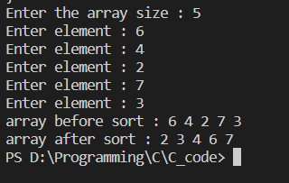

Date: | Signature

Practical 9
BST Algorithms with Operations
- CREATE
- INSERT
- DELETE

Program:
#include <stdio.h>
#include <malloc.h>

struct node
{
int data;
struct node *left;
struct node *right;
};

struct node *createnode(int data)
{
struct node *n;
n = (struct node *)malloc(sizeof(struct node));
n->data = data;
n->left = NULL;
n->right = NULL;
return n;
}

void postorder(struct node *root)
{
if (root != NULL)
{
postorder(root->left);
postorder(root->right);
printf("%d ", root->data);
}
}

int isBST(struct node *root)
{
static struct node *prev = NULL;
if (root != NULL)
{
if (!isBST(root->left))
{
return 0;
}

if (prev != NULL && root->data <= prev->data)
{
return 0;
}
prev = root;
return isBST(root->right);
}
else
{
return 1;
}
}

struct node *insert(struct node *node, int data)
{
/* If the tree is empty, return a new node */
if (node == NULL)
return createnode(data);

/* Otherwise, recur down the tree */
if (data < node->data)
node->left = insert(node->left, data);
else if (data > node->data)
node->right = insert(node->right, data);

/* return the (unchanged) node pointer */
return node;
}

struct node *postorderpredecessor(struct node *root)
{
root = root->right;
while (root->right != NULL)
{
root = root->left;
}
return root;
}

struct node *deletenode(struct node *root, int k)
{
// Base case
if (root == NULL)
return root;

// Recursive calls for ancestors of
// node to be deleted
if (root->data > k)
{
root->left = deletenode(root->left, k);
return root;
}
else if (root->data < k)
{
root->right = deletenode(root->right, k);
return root;
}

// We reach here when root is the node
// to be deleted.

// If one of the children is empty
if (root->left == NULL)
{
struct node *temp = root->right;
free(root);
// delete root;
return temp;
}
else if (root->right == NULL)
{
struct node *temp = root->left;
free(root);
// delete root;
return temp;
}

// If both children exist
else
{

struct node *succParent = root;

// Find successor
struct node *succ = root->right;
while (succ->left != NULL)
{
succParent = succ;
succ = succ->left;
}
if (succParent != root)
succParent->left = succ->right;
else
succParent->right = succ->right;

// Copy Successor Data to root
root->data = succ->data;

// Delete Successor and return root
free(succ);
// delete succ;
return root;
}
}

int main()
{
struct node *root = NULL;
int option, val;
printf("Enter your choice");
while (1)
{
printf("\n 1. Insert Element");
printf("\n 2. Delete an element");
printf("\n 3. Display the tree");
printf("\n 4. Exit");
printf("\n Enter your option : ");
scanf("%d", &option);
switch (option)
{
case 1:
printf("\n Enter the value of the new node : ");
scanf("%d", &val);
root = insert(root, val);
break;
case 2:
printf("\n Enter the element to be deleted : ");
scanf("%d", &val);
root = deletenode(root, val);
break;
case 3:
printf("\n The elements of the tree are : \n");
postorder(root);
break;
case 4:
exit(0);
}
}

return 0;
}

OUTPUT
=======
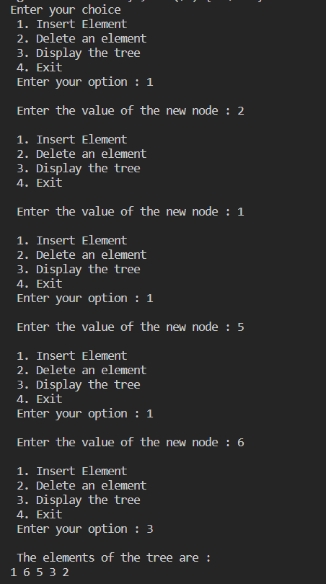

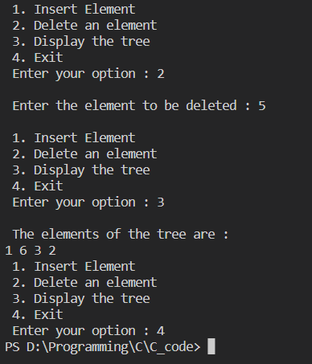

Date: | Signature

